Faculty User Guide
SBA Online Course Evaluations – Winter 2008

Student Information

Your students will be participating the Online Course Evaluation.

The activation window closes Sunday, April 20th.

The system is not activated outside this date range for student input.

What Students Need

In Internet Explorer, go to: https://www2.oakland.edu/ouevaluate
Make sure to include the "s" when typing https to designate that you are accessing a secure web site.

Students login to the system by using their Grizzly ID number (NOT social security number) and PIN.

There will be a link to the evaluations from the SBA home page (http://www.sba.oakland.edu). In addition, students should receive an email on the first day the survey is available.

Please remind the students that the information they provide is confidential and that you are not able to view the evaluations until after the class is finished.

How the System Works

- Once logged in, students will see a list of their currently enrolled SBA classes.
- Students must select one course at a time to complete the evaluation.
- During the activation period, students can re-visit the site to complete the evaluations; however, once the evaluation for a class is submitted, students can not retake the evaluation for the class.

Screen 1: Login on to the system Screen 2: Select a class to begin
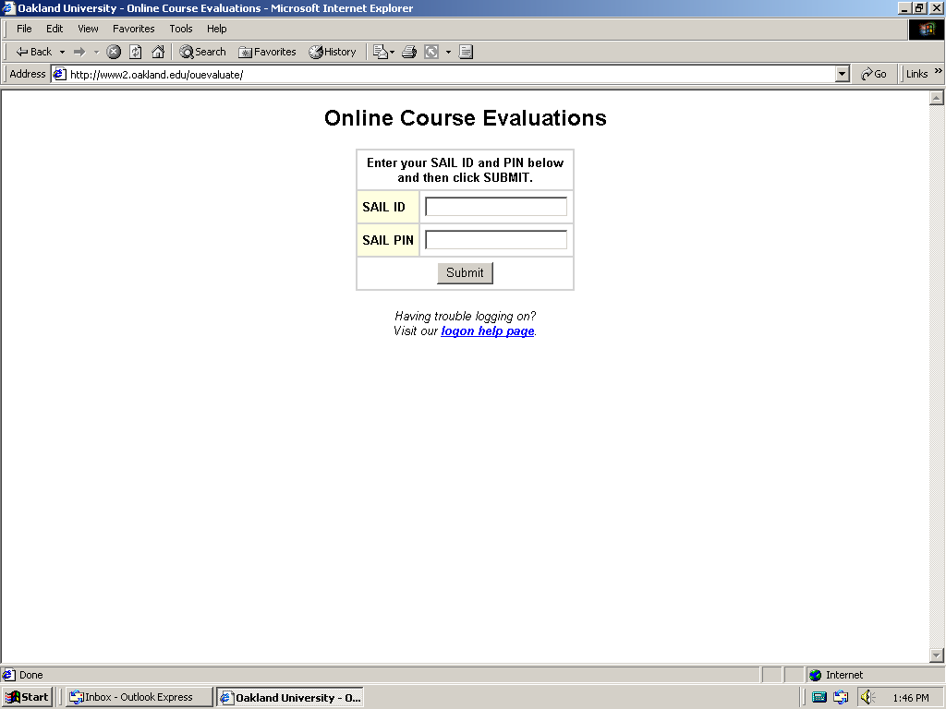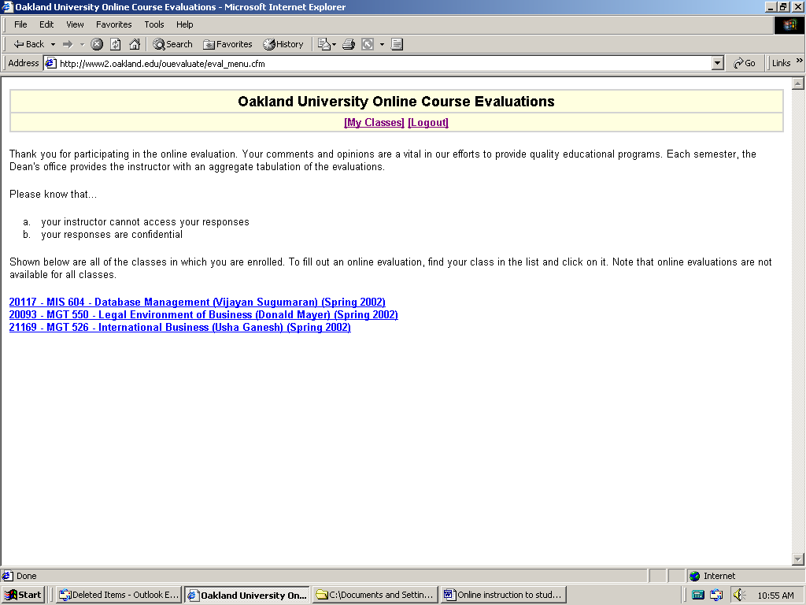

Screen 3: Begin the evaluation for the class
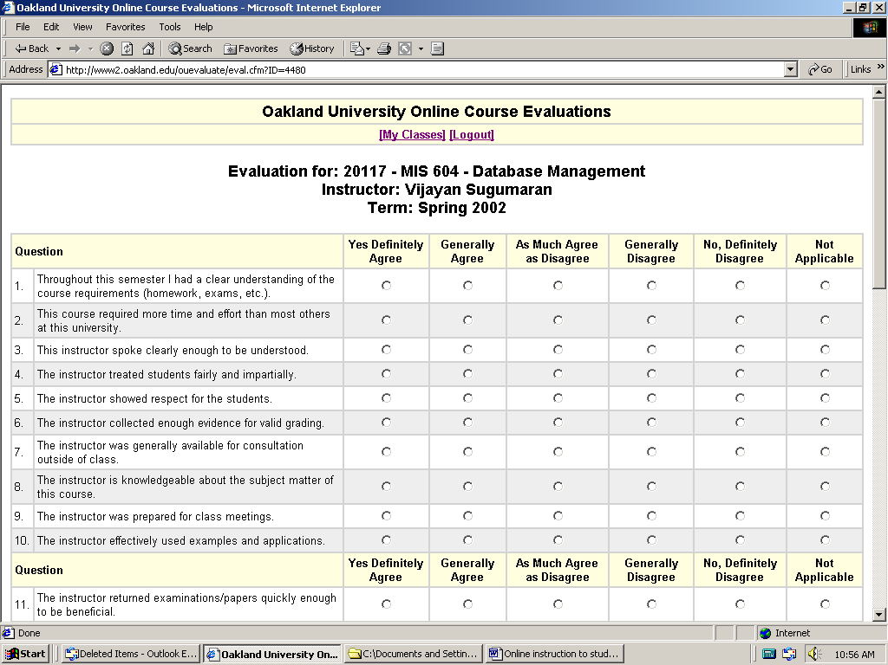

Faculty Information

- You will be able to view the evaluation results two weeks after the window closes – after classes have ended and grades have been submitted.

What Faculty Need

- In Internet Explorer, go to: https://www2.oakland.edu/ouevaluate/manager
Make sure to include the "s" when typing https to designate that you are accessing a secure web site.
- There is also a link to Faculty Evaluation Manager from Student/Faculty Resources on the SBA home page (http://www.sba.oakland.edu).
- Note that your students will not be able to login to this site.
- Faculty can login to the system by using their OU Computing Account (OUCA) and password.
- Your OUCA is your email account username and password.
- Please note that this is a CHANGE from previous semesters!

How the System Works

Screen 1: Faculty Login - Enter your OUCA username and password.

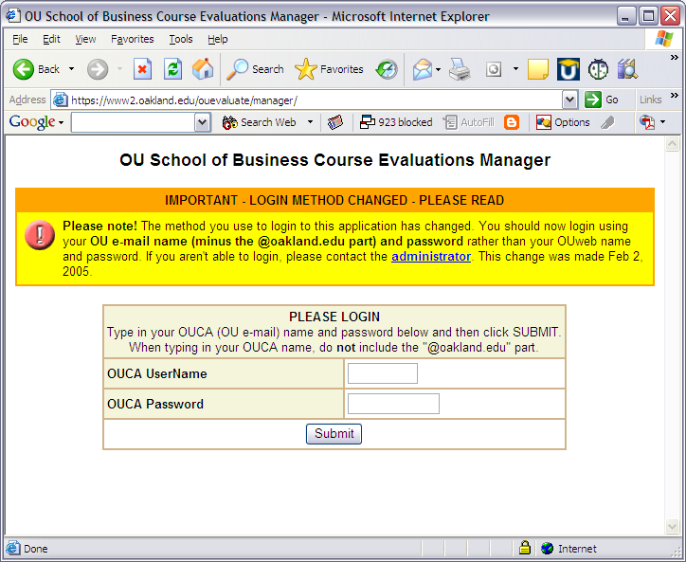

Screen 2: Click on REPORT to view a report for the course. This link will not be active until 5 days after the end of the term or if the course has not collected any responses. You can see how many responses have been collected by referencing the number in parenthesis beside the report link.

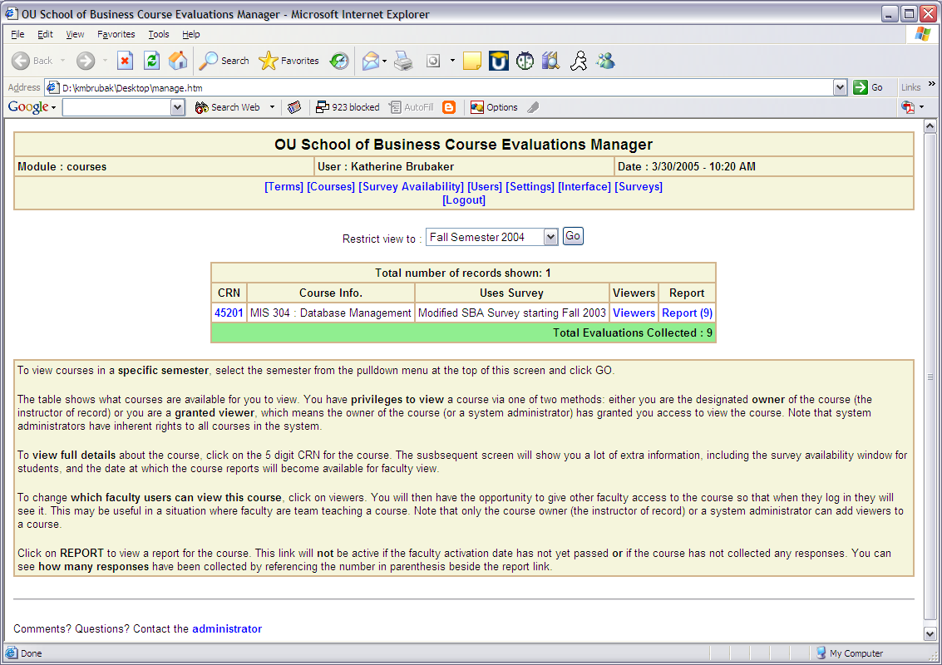

Screen 3. You can download the results to a Word or Excel file. See instructions at the bottom of the page.

